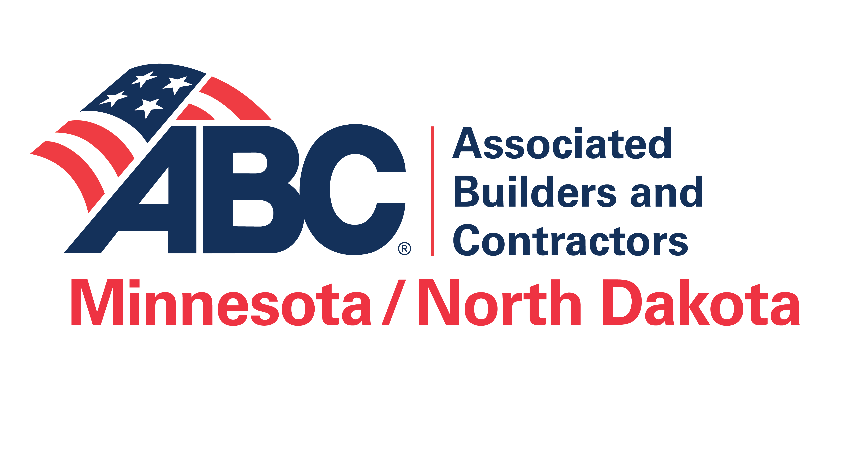
2026 EIC Awards Timeline
Week One - Preparation Time
The 2026 Excellence In Construction Awards program materials are received from MN/ND ABC and reviewed. Determine what project your company will enter. It should be a project with a background story and/or presented a challenge to your group or was innovative. Be able to explain how you overcame the difficulties.
Select a staff person to serve as the Project Manager. The Project Manager will oversee scheduling meetings, collecting data from staff and keeping the group on schedule.
Develop a brief checklist of items needed for each project submission.
Week Two - The Beginning
Your company should answer all questions on the entry form. Is the entry form the 2026 version?
The Project Manager will schedule a meeting date with the project managers, Safety Director and Marketing Department. Provide questions they will need to answer for this project ahead of time so they know what will be expected of them. You may be a smaller company and not have all these departments, but that is ok. However, it will be important for the Project Manager to keep on task, even if it is only a few minutes a day. Remember, you are only competing against other contractors in your same category so you can do it!
Contact all the companies you wish to receive references from (owners, architects, general contractors, specialty contractors, etc.). Hopefully the references will be on their letterhead and make color copies for your 3-ring binder. Summer will be the most difficult time to collect these from construction companies so you should get a head start. If an owner would like to remain anonymous, they are welcome to do so. However, we may need them for a reference. Assure them that no references are published by ABC.
Set up a three-ring binder and use tabs to organize information. Follow the order of the entry form and insert the form, charts, referrals, etc. as they are received.

Week Three - Staff Meeting Scheduled
This meeting can be done as a group, or a one on one. The group meeting can be helpful because it will bring everyone together as a team and help with ideas or remember parts about a project completed months ago.
• Safety Director - should be able to complete the safety form and required materials or tell the EIC Project Manager where these items can be found. Was there a site-specific safety manual? Was there any site-specific safety training required? Have you filled out your STEP application? If not, one is available online at the MN/ND ABC website. Complete and send to the local office with your OSHA 300A log for a certificate. Also, don’t forget to sign the drug free workplace pledge.
• Project Estimator/ Project Manager for the Job - Other than the EIC Entry Project Manager, this individual/s will be responsible for:
– Scope: the basic information about this project. It is also the first thing the judges read. Be sure to include all the items outlined in the application. A clean page layout increases the readability and using bullets allows the judges to easily learn about your project.
– The Narrative: the story of your project, what makes this project special and why does it deserve an award? What were the challenges, obstacles, site conditions or extenuating circumstances and how did you deal with them? You should communicate this clearly and succinctly. Winning projects use creative subheads and a few small photos (thumbnails) to capture the judge’s attention. This is your company’s chance to brag.
– Identify the companies that helped work on this project and please provide contact information since they will be invited to attend the EIC Awards Ceremony if the project wins.
• Marketing Department - Gather supplemental materials that help tell the story of your project. Press releases, history about the property, etc. They will also be responsible for photos. You will need before, during and after photos for full credit. Submit photos of key areas, challenging construction especially before areas are covered by finishes (mechanical, electrical, etc.). Please follow the guidelines for photo requirements. Please gather all social media on the project. The project books do get judged by their covers. Overall presentation category can be the easiest area to gain full points. Have them create a design theme for the binder that will carry through and be aesthetically pleasing. Creativity allows projects to stand out and can be incorporated into the cover design and tab dividers.
- AQC: Have you qualified for STEP Gold or higher two years in a row? You should apply for Accredited Quality Contractor recognition through ABC National. It will give your project two additional points in the local and national competitions. AQC designations will also be featured next to your company listing in the National and local ABC directories.
Week Four - Keeping On Task
Be in contact with all departments to make sure they are staying on task. As the information is completed, start working on assembling the binder. The scope should be completed as well as a rough draft of the narrative. Have a coworker not involved in the project read for review and input. The most effective binders are those that break down each question, especially in the safety section where more is required than a yes, or no answer. Follow the format and place behind the correct tab. please use color and theme in your binder, carry it through from the cover to the Contractor tab. If you would like to see samples of books, please contact Jeni at the ABC office 952-941-8693. There are also samples of scope and narratives on the ABC National Website.
Week Five - Finalizing of Information
Final draft of the narrative should be completed. Make sure everyone has had the chance to read, make suggestions and proof. Does it tell your story, and does it answer why this project is special? Are the questions broken down and answered? Is it easy to read? Photos should be chosen of before, during and after. Print on photo paper if you have time and place behind the tab and save on the disk. All contractor information has been collected and printed with contact information, mailing address and phone number. Place it behind the Contractor tab and include an electronic version in word or excel format on your flash drive. In addition to the photos on the flash drive, please include your subcontractor list as well.
Have you received your referral letters? If not, make your phone calls. Are they on letterhead and have color copies of the originals have been made for your book?
Did you make a copy of your STEP certificate in color? Are you AQC and did you make a color copy of your renewal letter?
Week Six - Meet With Your Team Again
Does everyone have his or her information to you in final format? Make sure everyone has had a chance to proof all the sections. Is it esthetically pleasing and a binder that the team is proud of?
Week Seven - Wrap Up
Are there any unanswered questions in your application? All questions should be answered, however, if the question does not apply to your project, you should state that it does not and why (subcontractor).
Are all materials in a three-ring binder with the project information on the cover and spine? Is the disk in the binder and does it include your photos, the list of contractors who will be invited if you win and your write up for the award brochure? Please indicate which photo you would like as your main award photo for your plaque and the two smaller photos for printing in the award brochure.
Have you paid your entry fee? If not, please include a check made out to ABC for $250 per project.
Submission Deadline
September 11, 2026 - Please send to the MN/ND ABC office at 10193 Crosstown Circle, Eden Prairie, MN 55344
Judging Date
October 7, 2025 - Judging will be held on the first week in September at the MN/ND ABC office. If your project receives an award, you will be contacted by October 9th. If you do not receive a call, assume that your project did not win. All projects will be returned with the judges’ comments.
National Award Competition Deadline – October 30, 2026
Please register your project online through the ABC National Office on their website at www.abc.org. National has a strict policy for submission dates so please refer to their guidelines. If a project wins at the local level, your company will be able to continue onto the National competition run through ABC National. Please remember, your entry is now entered electronically.
We strive to make the National guidelines as close to the local competition as possible, but please read the national application carefully since some of the questions may be different. Use the local competition judges’ comments to improve your entry and increase success in the National competition.
Local Award Competition Ceremony
January 21, 2027 - The Metropolitan Ballroom, Golden Valley, MN/ND ABC members and your contractors will be invited to the ceremony. If your company would like to invite your contractors personally, please let us know in advance so that we may send you the invitations. You can issue press releases for your winning projects, increase employee morale and build your experience portfolio of outstanding projects. Put references on your website with winning project pictures.
National Award Competition Ceremony
March 10, 2027 in Denver, CO.

